Homework2





The PCA and KPCA transformations of data
电 话
专 业
课程名称
班 级
学 号
姓 名

年 月 日
Abstract
It should be an explicit summary of the report that states the problem, the methods used, the major experiments, discussions and conclusions.

1. Introduction

2. PCA and KPCA
2.1 Theory of PCA and KPCA
In this section, the background, principle and derivation formula about PCA and KPCA should be described soundly.
2.2 The PCA and KPCA for "data_PCA.txt"
In this section, an actual project is required to carry out with PCA and KPCA. The steps and results of processing should be given and analyzed in detail. The original date was given as follow, the different data sets are marked as red (1st-128th data in "data_PCA. txt") and blue (129th-256th data in "data_PCA.txt") respectively.

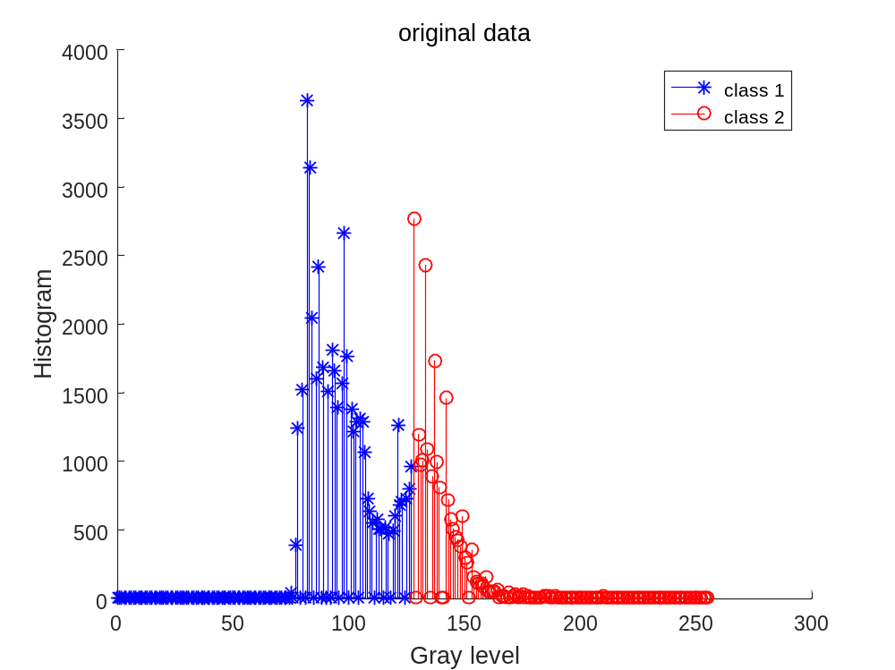

3. Conclution
Appendix
Give the used Codes
Specify your environment and how to execute.

